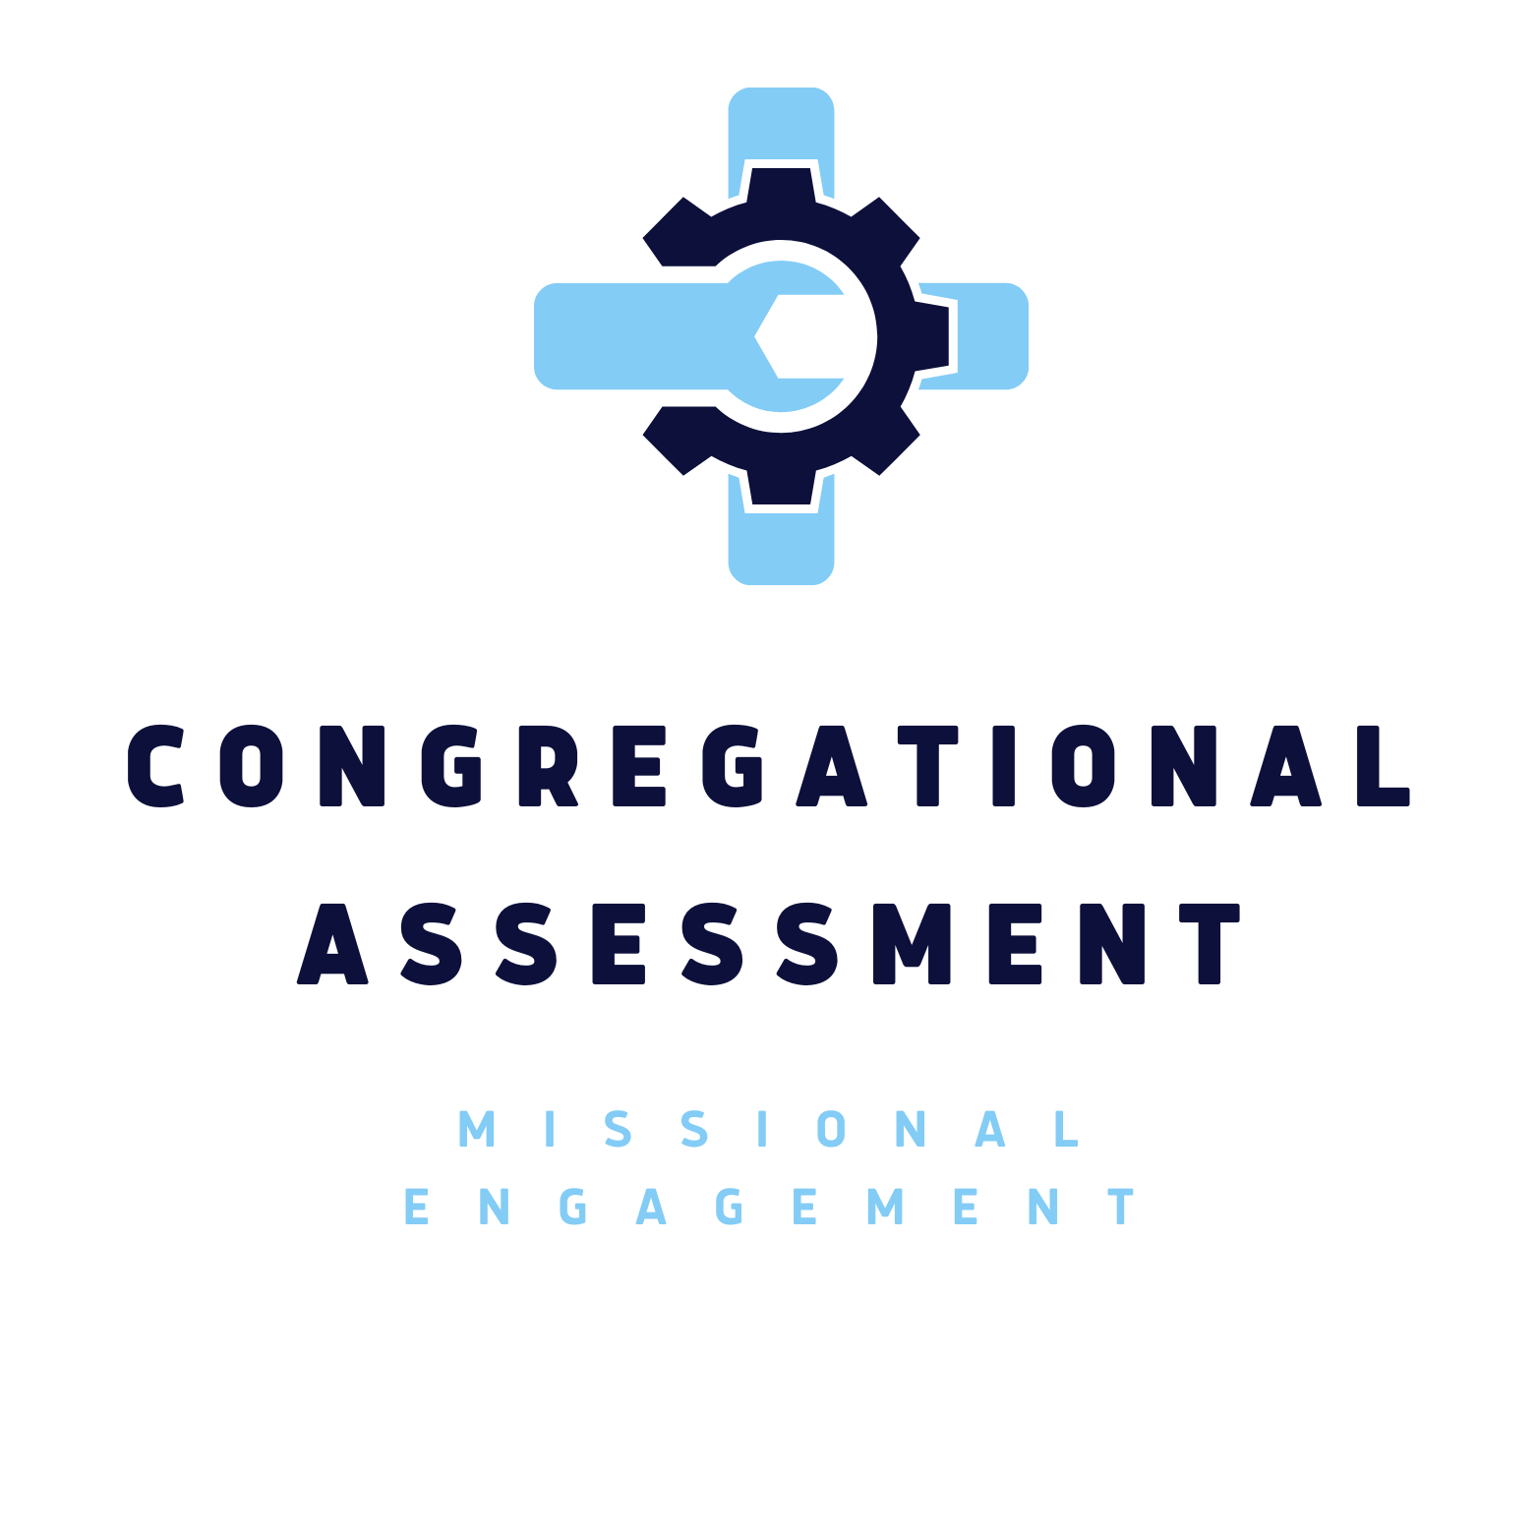


Dr. Martin Spoelstra
Classis Quinte Home Missions
Resonate Local Mission Leader
Pastor of Discovery CRC
905 259 3399
martin@discoverychurch.ca

Missional Engagement: A Congregational Assessment Tool
Congregational Assessment Tool

Purpose
God has uniquely given each church a cultural task of knowing and understanding their unique context, a theological task to understand where you are in the biblical story as a church, and a missionary task to communicate the gospel to that unique context. This assessment tool is to help you understand where you currently are in carrying out God’s purpose for your congregation. It is NOT designed to help you accomplish that purpose (contact your Resonate Local Mission Leader or your Thrive representative for next steps).
This assessment will help your church leadership teams to:
- Recognize who your congregation is right now, as missionaries. This will help you get a baseline of where you’re at as a congregation in order for you can recognize what steps you need to make to move forward.
- Assess the current tools you are using for making disciples. Many of these may be very effective and need to be further resourced and developed. Other tools may be ineffective and need to be removed and/or replaced.

Definitions
"Disciple: a person who learns to be like Jesus and learns to do what Jesus would do. Discipleship is the process of becoming who Jesus would be if he were you. Someone whose life and ministry reflect the life and ministry of Jesus." Mike Breen, 3DM

“Missionary: a disciple who is taking seriously Jesus’ calling to go (John 20:21, Matt 28:16-20) into our homes, neighbourhoods and workplaces introducing people to Jesus and proclaiming the Kingdom of God. This is the practice of EVERY disciple.” Dr. Martin Spoelstra, Discovery Church

Missional Engagement
Church outreach has generally taken the form of community service or evangelistic efforts. However, real missional engagement entails the building of authentic, organic, and consistent relationships that lead to intentional discipleship.

How to Use this Tool.
“Missional Engagement: A Congregational Assessment Tool” is designed to be used by church leadership teams (full councils, boards, ministry teams, etc.) in the context of a larger visioning retreat or as a short portion of several consecutive, regular meetings.

Congregational Assessment: Who Are We Now?
- Based on your experiences, which Biblical story best captures the current character of your congregation?
- A vine bearing good fruit (John 15).
- A valley of dry bones, waiting for new life (Ezekiel 37).
- Corinth: a church in conflict (I Corinthians 4-5).
- Timothy: eager to engage in new work but wanting and needing guidance and instruction (2 Timothy 1).
- The disciples prior to feeding the 5000: Sensing the need yet overwhelmed by the task (Matthew 14:13-17).
- Eli and his sons: Difficulty in passing mantle of leadership to the next generation (I Samuel 2).
- On the Road to Emmaus: Sad and disheartened like Cleopas and companion as they walk from Jerusalem to Emmaus on Easter evening (Luke 24).
- Fishing boat: Tossed on stormy seas (Luke 8:22-25, etc.).
- Jonah: Avoiding God's call (Jonah 1).
- Waiting patiently on God (Isaiah 40).
- Laodicea: A church with lukewarm faith (Revelation 3).
- Other: ____________________

- Spend some time discussing why you feel this way. Come to a consensus as a group on which biblical story you identify with the most (two stories might fit better than one).
Notes:



Making Disciples
- What process do you have in place for introducing new people to Christian discipleship?
- Do you hold New Member classes (or something equivalent)? How many people attended these classes this past year?
- Is an introduction to Christian discipleship part of that class?
- In the CRC, we measure numbers of new disciples each year in the membership category "Received by Profession of Faith." How many new members were received in the past year by Profession of Faith or adult baptism?
- Were there people who were welcomed by your congregation as new disciples but did not become members? How many in the past year?
- Do you have a different method for making disciples other than the process for becoming a member? Describe them.
- How pleased are you with the current methods for making disciples?

On the following scale of 1 to 4, please rate your system for making disciples:

We don’t intentionally make disciples. | We’re considering starting a disciple-making system. | We have parts of a system in place. | Disciple-making is what we do.
1 | 2 | 3 | 4

Notes 

Discipleship Programs
Practicing spiritual disciplines is an extremely important piece of seeking after holiness and spiritual maturity, yet it is only half the picture. The other half is our God-given responsibility to the world around us. The fact is you cannot be a true disciple without being a missionary. Our Bible study and prayer must focus on both.
- What percentage of your average worship attendance is involved in a small group devoted to discipleship?
- If not small groups, do you offer other forms of discipleship support? Describe them.
- Does your current method differentiate between discipleship training and leadership training?
- If so, what kind of training for spiritual leadership do you offer to disciples in your faith community? If not, is there a component within the discipleship groups that targets the development of spiritual leaders?
- How many lay leaders are involved in leading small discipleship groups?
- What percentage of your faith community’s lay leadership is involved in small discipleship groups, not as a leader, but as a participant?

On the following scale of 1 to 4, please rate your small group and disciple support system:

We have no plans for discipleship leader training. | We’re considering a discipleship leaders training program. | We’re starting a discipleship leader training program right now. | We have discipleship leader training in place.
1 | 2 | 3 | 4

Notes:

Disciples Transforming their World.
- How do individuals in your congregation live out their Christian discipleship in the world? Give as many examples as you can think of for the members of your congregation.
- How does your congregation facilitate the engagement of members in responding to the hurts and hopes in its mission field?
- In this past year, what percentage of individuals in your congregation participated in direct service missions organized by your church for transformation of your mission field?

On the following scale of 1 to 4, please rate your congregation's success at engaging people in direct ministries of transforming your community:

We give money but aren’t directly involved in transformational missions. | We have a few who are directly involved in transformational missions. | Many are directly involved in transformational missions. | Most are directly involved in transformational missions.
1 | 2 | 3 | 4
Notes:

Engaging Your Mission Field
- What do you consider to be your congregation’s mission field? (For example: 1-Km radius of the church? 2-Km? A specific neighbourhood? An affinity, cultural or linguistic group?)
- How many people live within your mission field?
- What is their average age? Income level? Family situation? What are the main subcultures?
- How are these demographics and subcultures different than the make-up of your congregation?
- How has the congregation shown flexibility in the last two years in engaging its mission field?
- What are the top three needs of people who live within your mission field?
- Who, outside of the congregation, has confirmed these as pressing needs (school administrators; social workers; law enforcement; the persons with whom you might walk in ministry)?
- What are your strategies for ministering to the three most pressing needs identified in #6 above?

On the following scale of 1 to 4, please rate your congregation's engagement in your local mission field.
We haven’t thought about our mission field outside our church. | We know there is a mission field outside our church but haven’t done much about it. | We have a plan in place to address the changes needed for our church to be active in our mission field. | We know our mission field and are working to meet their needs.
1 | 2 | 3 | 4
Notes:

Overall Rating and Reflection
On the following scale of 1 to 4, please rate your congregation's overall rating based upon your previous discussions.
We don’t leave the building. | At the doorstep. | On the sidewalk. | Walking alongside the community in direct ministry to community need.
1 | 2 | 3 | 4

- Is your congregation comfortable with this rating? Please explain.
- What do you think it would take to move up a step?
Notes:

Next steps

- Identify one area you want to improve on.
- Once you’ve identified that area, assign someone to seek out resources that your team can study.
- Connect with your Resonate Local Mission Leader or your Thrive representative for a consultation.

